Worksheet 4.1

Survey Template

This worksheet contains a ready-made template for the Go Human survey which is a method used to capture critical information from participants on travel behaviors patterns and activation elements.

Instruction: Use the following document for the Go Human survey. Fill in your City/Agency in the spaces provided below, [insert City here]. Feel free to adapt the following pages to your activation goals. Insert your logo at the bottom right corner of the last page.

[Insert City here] Participant Survey
Thank you for providing your feedback. Please return this survey to the event booth or box near the temporary street improvements. [Optional]: If you would like to be entered into the raffle to win a prize, please provide your email address or phone number in the space on the back.

1. How did you hear about this event?
Website
___ Social media (Facebook, Twitter, Instagram, etc.)
___ Email
___ Word of Mouth
___ Poster / Postcard / Sign/ Banner
___ Did not know about this event until I arrived
___ Other: ________________________

2. How did you get to this event?
___ Walk
___ Bike
___ Skate
___ Family/Personal Vehicle
___ Public Transportation (bus, train, etc.)
___ Taxi/Shared Vehicle (Lyft, Uber, etc.)
___ Motorcycle or Scooter
___ Other:________________________

3. On a typical day, how do you travel around your community? Check all that apply.
___ Walk
___ Bike
___ Skate
___ Family/Personal Vehicle
___ Public Transportation (bus, train, etc.)
___ Taxi/Shared Vehicle (Lyft, Uber, etc.)
___ Motorcycle or Scooter
___ Other:________________________

4. What keeps you from walking or biking more in your community or neighborhood? Check all that apply.
___ Not enough places or infrastructure to walk or bike (sidewalks, bike lanes) safely
___ Heat/ weather
___ Destinations are too far to walk or bike
___ Not in the habit/Don't think about it
___ Concerned about unsafe drivers
___ Concerned about crime or harassment
___ Need to transport children/people/bags
___ Don’t have enough time
___ I don’t have access to a bicycle
___ Other: ______________

5. Check the top 3 things from the list below that would improve [insert City here] for people walking.
Wider sidewalks
___ Complete missing sidewalks
___ Improved street crossings
___ Public space/parks
___ Sidewalk lighting
___ Lower vehicle speeds
___ More shade measures such as shade trees or breezeways
___ Improved personal safety
___ Other:________________________
___ Nothing. OK as is.

6. Check the top 3 things from the list below that would improve [insert City here] for people biking.
___ More bike lanes on the road
___ More bike lanes protected from vehicles
___ More bicycle parking and/or amenities
___ Bike share
___ Driver education
___ Bicyclist education
___ Lower vehicle speeds
___ Improved personal safety
___ Other:________________________
___ Nothing. OK as is.

7.
Improvement | Does this improvement make you feel safer walking/biking? | Do you want this improvement permanently installed?
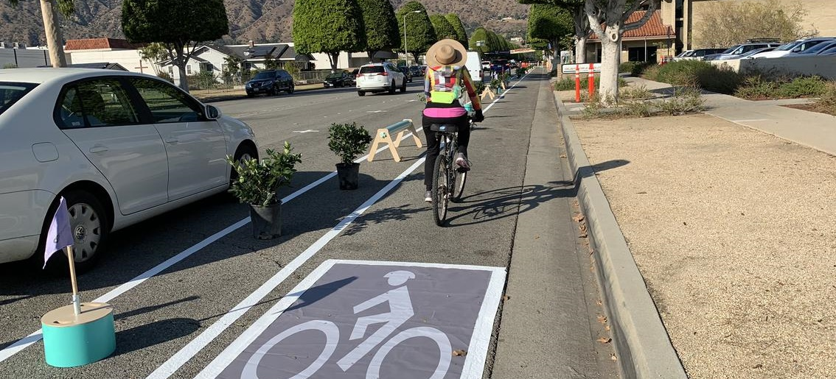  Buffered Bike Lane | ____ YES  ____ NO | ____ YES  ____ NO
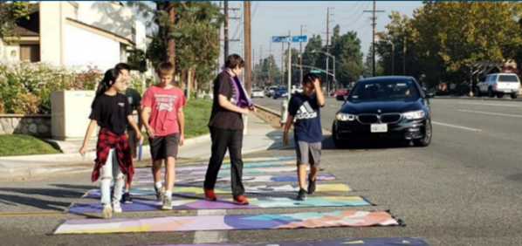  Artistic Crosswalk | ____ YES  ____ NO | ____ YES  ____ NO
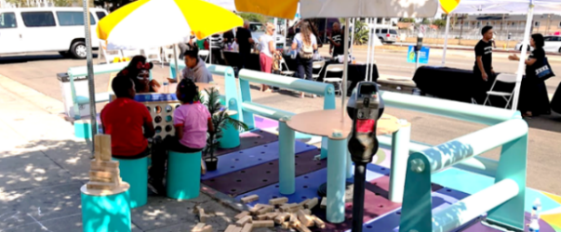  Parklet | ____ YES  ____ NO | ____ YES  ____ NO
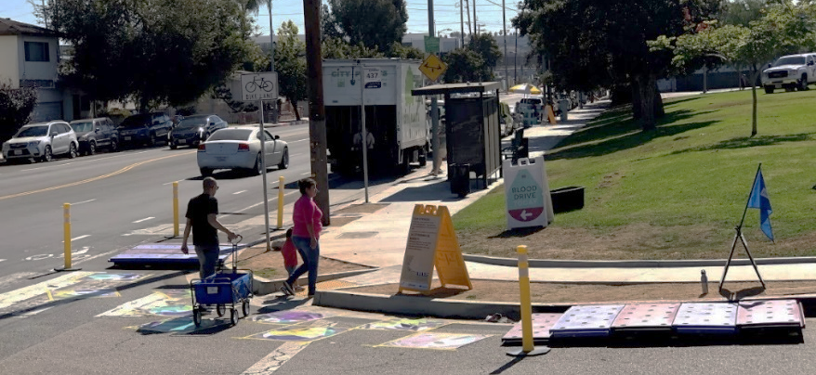  Curb Extension (Bulb-out)_ | ____ YES  ____ NO | ____ YES  ____ NO
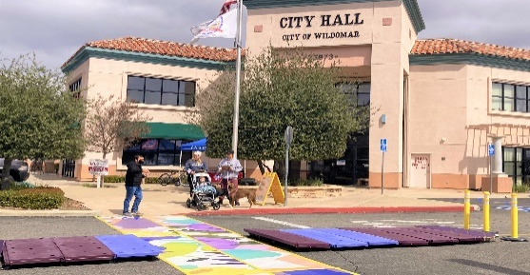 | ____ YES  ____ NO | ____ YES  ____ NO

8. Have you ever attended a community meeting hosted by the City to discuss transportation improvements in your community?

____ YES
____ NO

9. What is your gender?
____ Female
____ Male
____ Non-binary
____ Prefer not to answer

10. What is your age group?

____ Under 18
____ 18-24
____ 25-34
____ 35-44
____ 45-49
____ 50-54
____ 55-64
____ 65-74
____ 75 or older
____ Prefer not to answer

11. What is your race and/or ethnicity? Check all that apply.
____ Non-Hispanic White
____ Black or African-American
____ Asian/Pacific Islander
____ Hispanic or Latinx
____ Native American/American Indian
____ Other: ______
____ Prefer not to answer

Your logo here e

12. What is your zip code:
____ (zipcode 1)
____ (zipcode 2)
____ (zipcode 3)
___ Other:________________________

13. Do you have any other question, comments and/or concerns about walking or biking in [insert City here]?

14. [If applicable] If you would like to be entered into the raffle to win a prize, please provide your email address or phone number.

